FRAME

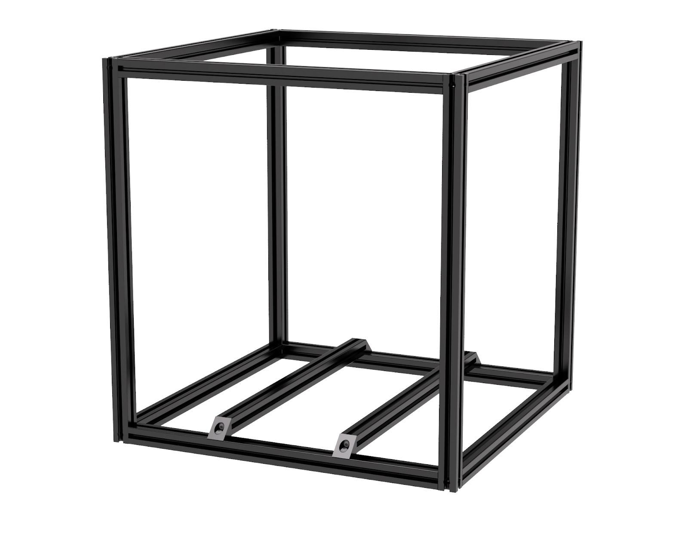

EXTRUSION REFERENCE



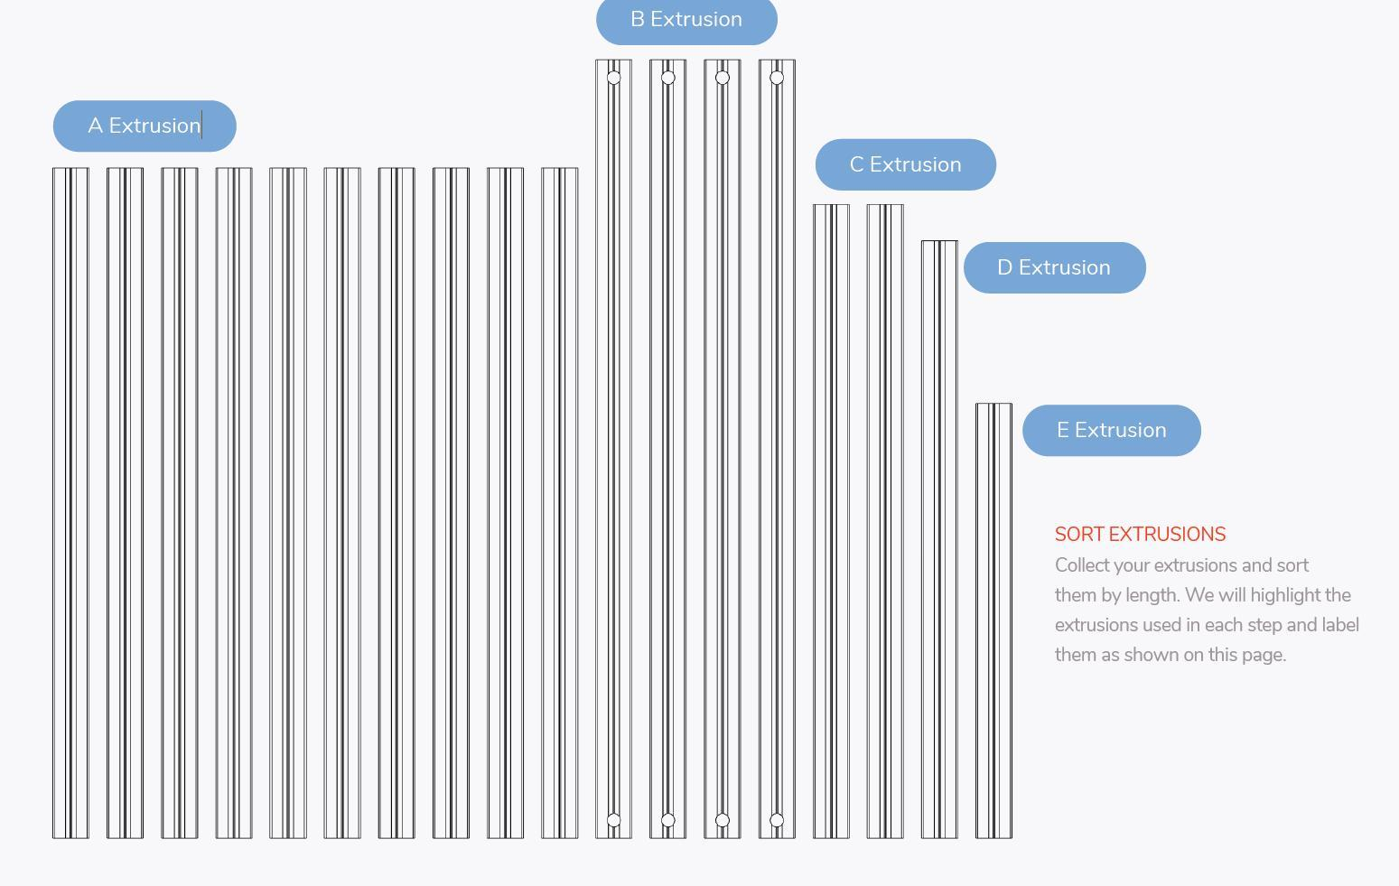

FRAME

Hardware needed |  | Tool’s needed |  | Parts needed
16 | M5X16 BHCS | Hex driver | 3.0 | 8 | A Extrusion

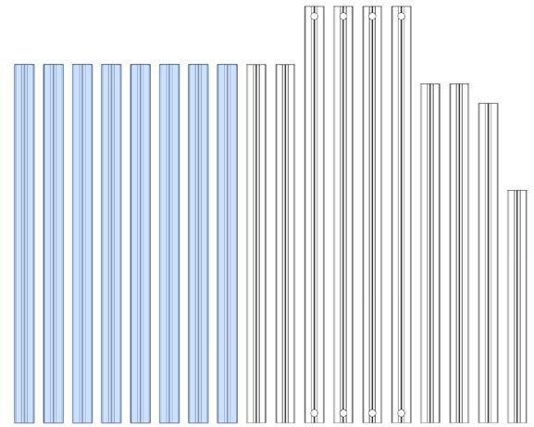
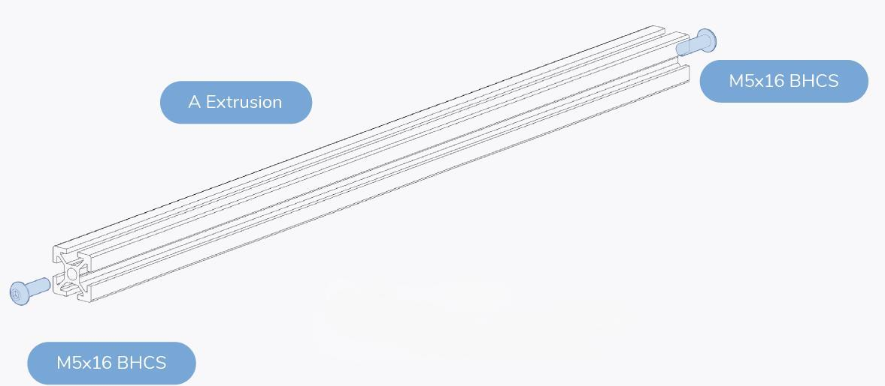

PREPARE 8 EXTRUSIONS
The extrusions are going to be used in this section. Prepare them as shown above, to make “A EXTRUSION SUB-ASSEMBLY”.
Leave a gap between the head of the screw and the extrusions, this will be needed in the following steps

FRAME

Tool’s needed |  | Parts needed
Hex driver | 3.0 | 4 | A Extrusion sub-assembly
 |  | 4 | B extrusions
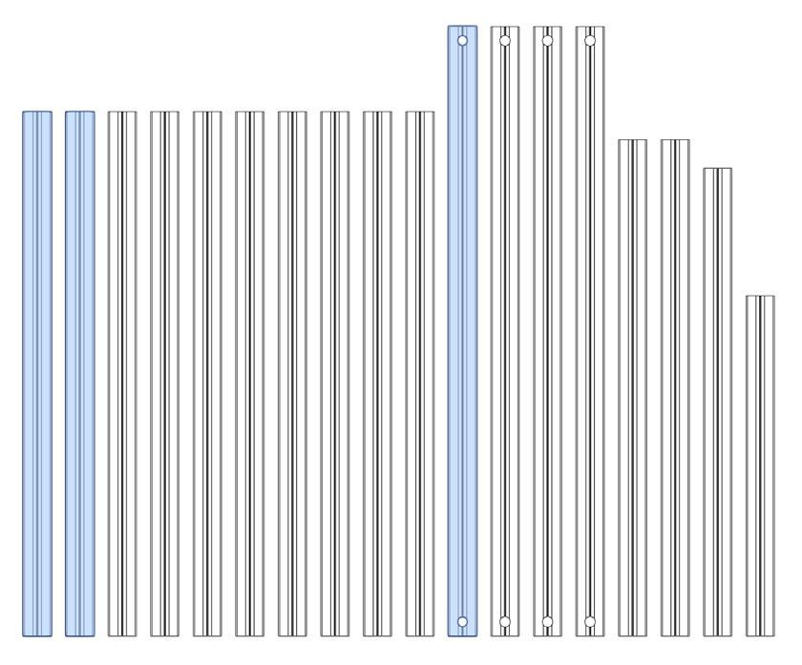

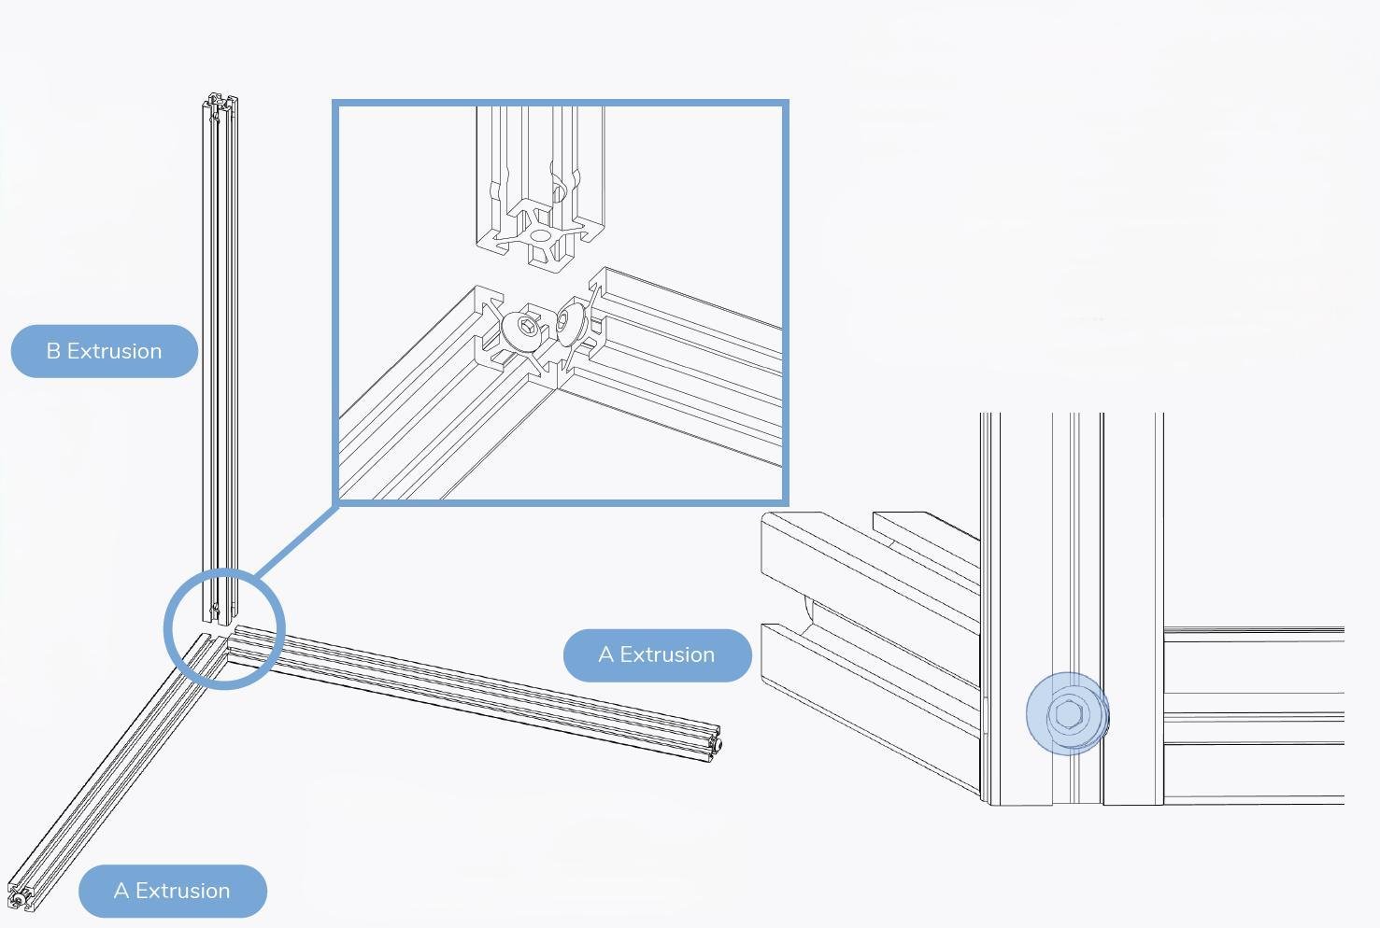

BUILD ON A FLAT SURFACE
Build the frame on a glass or granite surface to ensure you can get it as square as possible. Using something like 123 blocks or 90 degree squares may help.

Put the parts together, make sure to tighten the M5x16 BHCS firmly, checking that it’s square.
,
FRAME
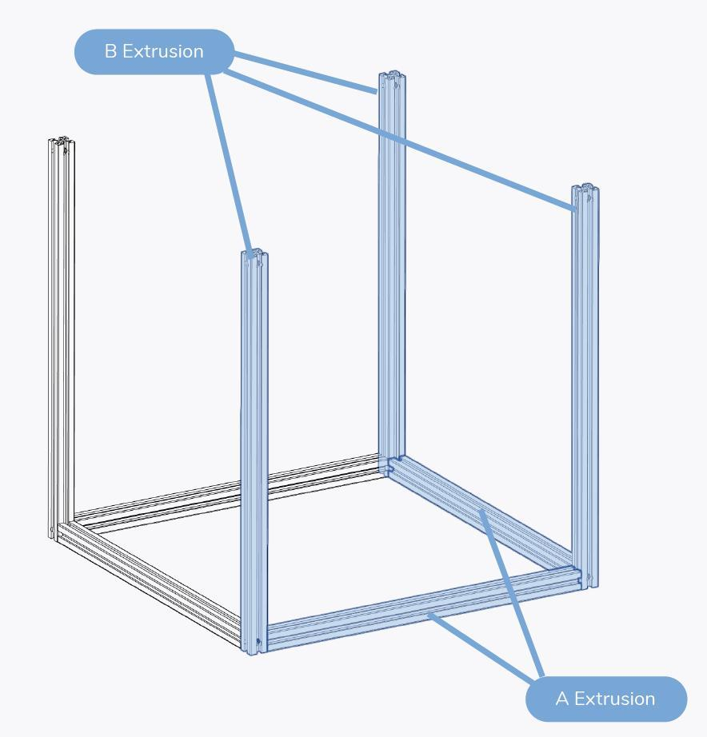

It should look like this.

FRAME

Tool’s needed |  | Parts needed
Hex driver | 3.0 |  | Frame
 |  | 4 | A Extrusion sub-assembly
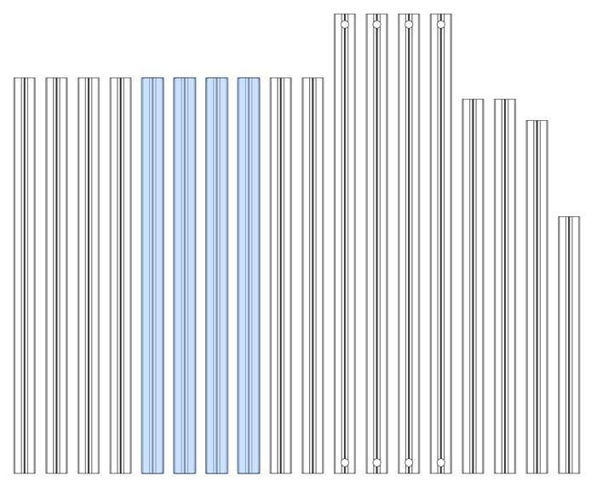
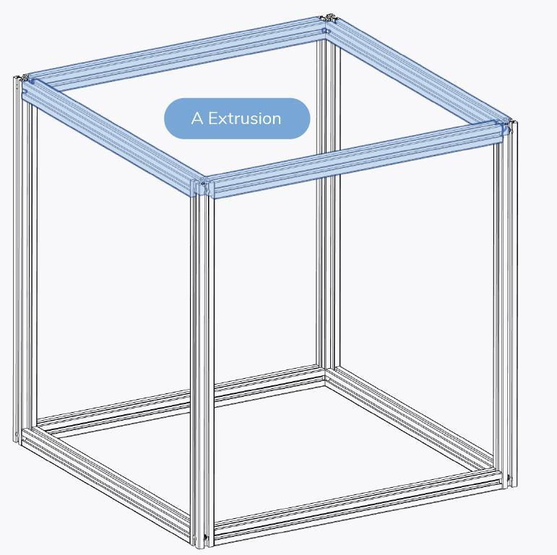
Double check that the frame is square.

FRAME

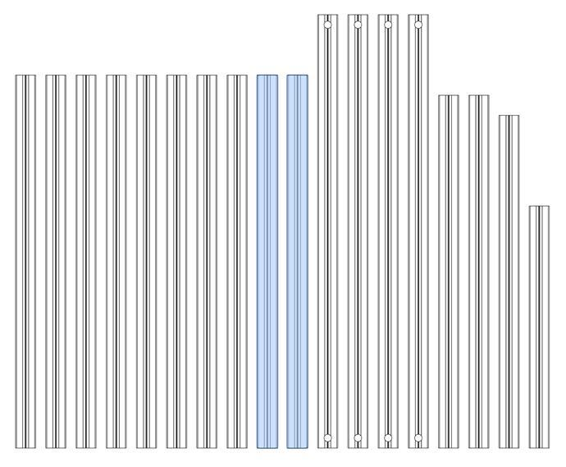
Hardware needed |  | Tool’s needed |  | Parts needed
4 | M5X16 BHCS | Hex driver | 3.0 | 2 | A Extrusion
 |  |  |  | 4 | Corner Brackets

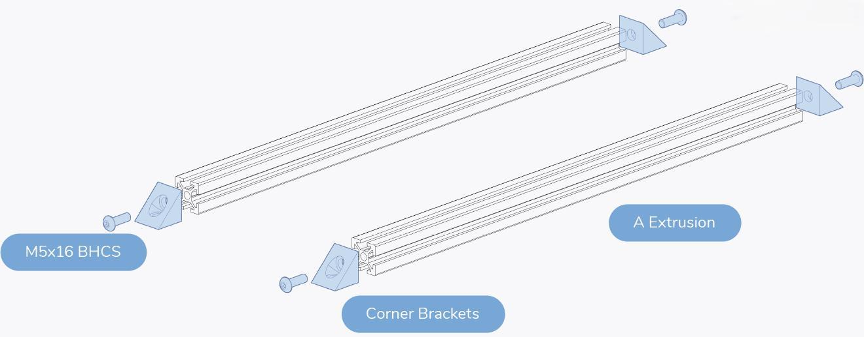

This is the “Bed attachment extrusions”

FRAME

Hardware needed |  | Tool’s needed |  | Parts needed
4 | M5X10 BHCS | Hex driver | 3.0 | 2 | Bed attachment extrusions
4 | M5 Precision Space

LOOK AT THE NEXT PAGE FOR PLACEMENT AND POSITION OF LOCATION!

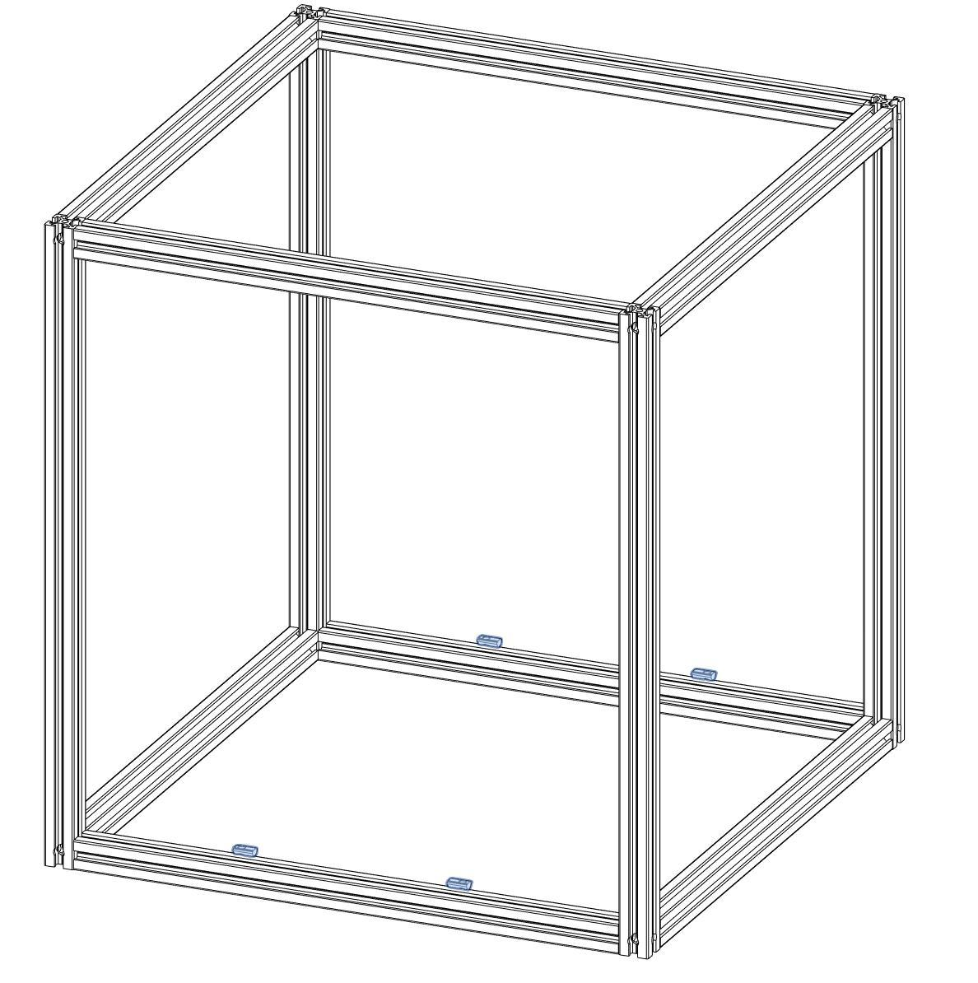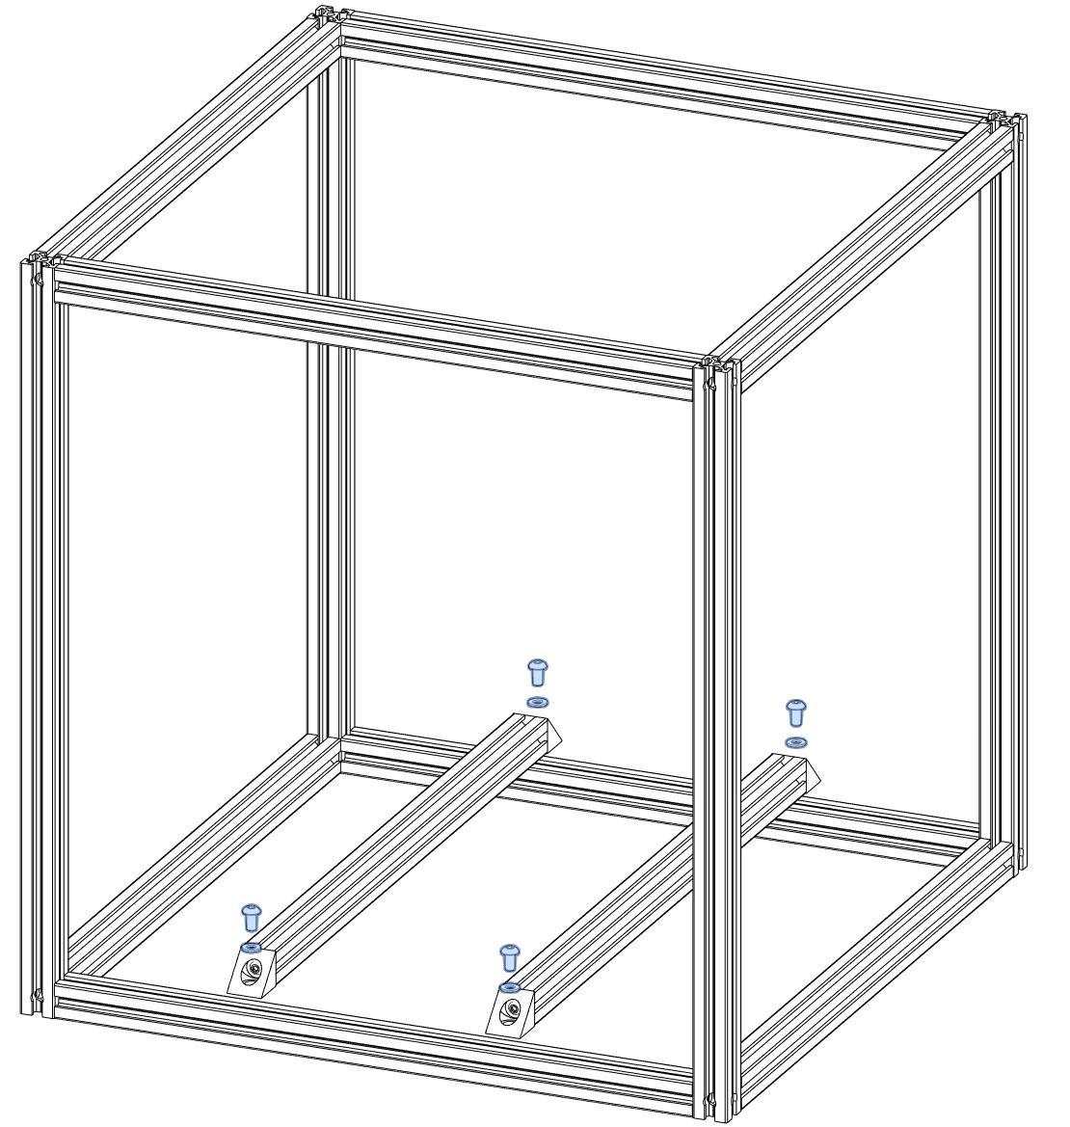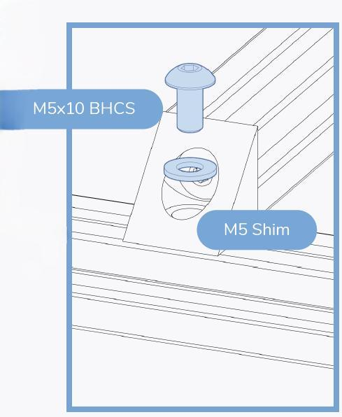
*The brass M5 Precision Spacer are used in place of the M5 Shim. This will be for all M5 Shims in the guide unless noted
FRAME
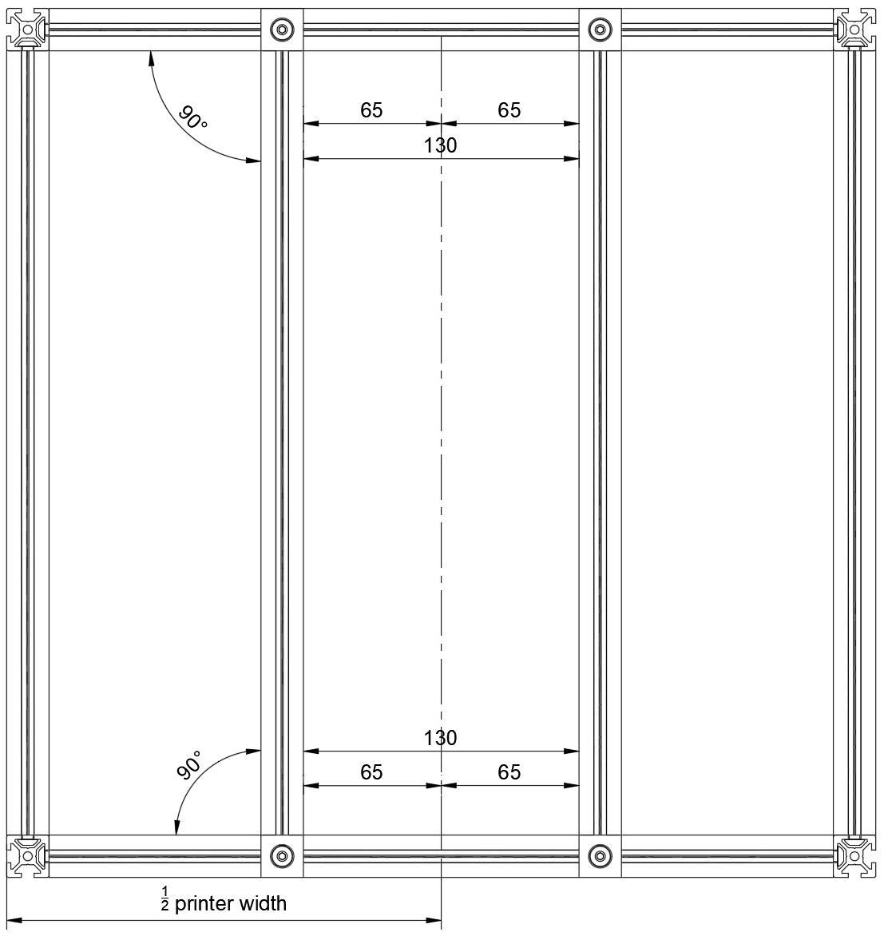

POSITION BED EXTRUSIONS  Find the centreline of the printer and  position the bed extrusions as shown  in the diagram to the left. The distance  between the extrusions is 130mm  centred on the centreline of the printer.  1/2 printer width for standard sizes:  250 spec 205mm  300 spec 230mm  350 spec 255mm | ALL UNITS ARE METRIC  If a unit is not specified  assume it’s metric.  All distances are called out in  millimeters.

FRAME

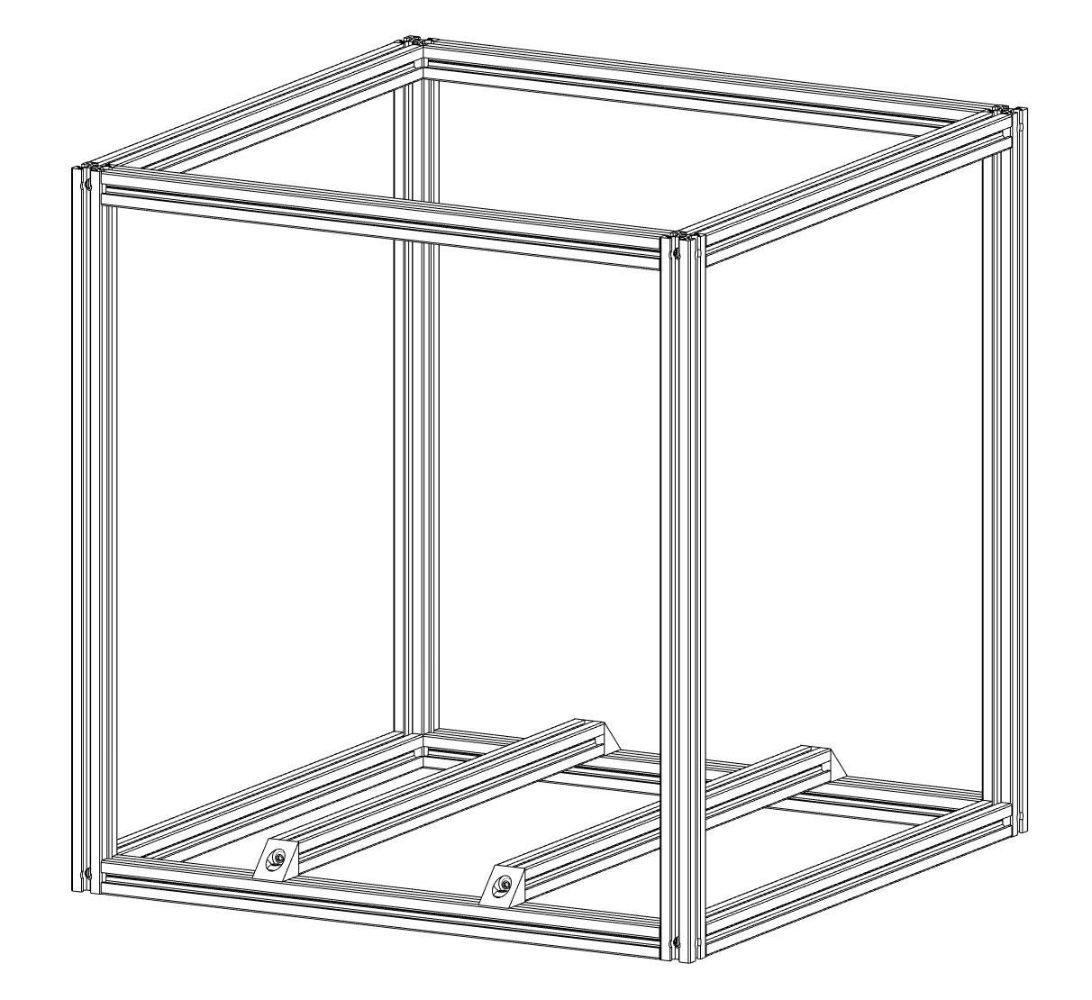
CHECK FOR SQUARENESS
Verify the angle of all corners and the overall squareness by measuring the diagonals. Refer to the second half of the linked video for additional information.

https://voron.link/kdtpzam

